Trip Agreement

AARMSCM Solutions will incorporate a new feature called **Trip Agreement** in SCMBizConnect.

A Client shall provide full details of recurring transportation requirement to the Transporter through this agreement to facilitate planning for the vehicle.

The provision made for the **Trip Agreement** in the SCMBizConnect is as shown below. Trip agreement is made between a client and a transporter by AARMSCM Solutions.

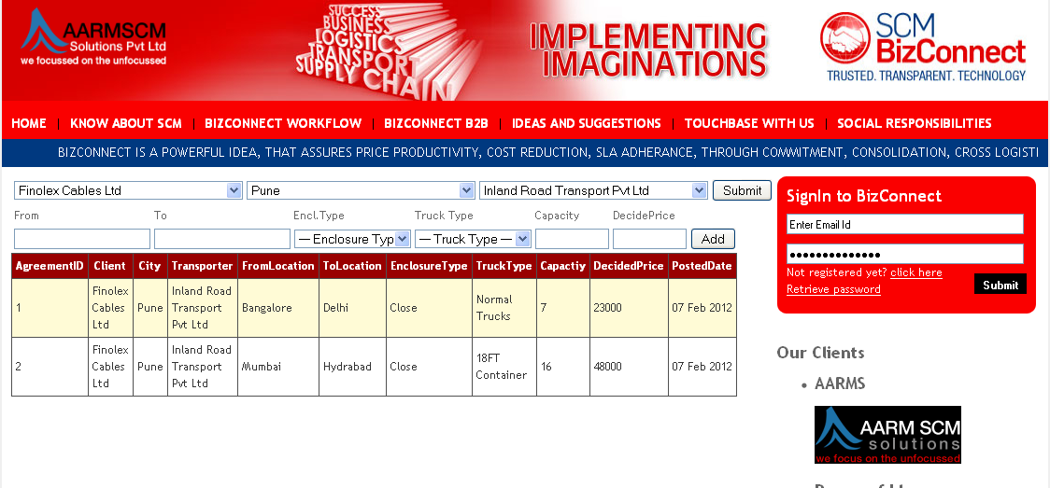

Trip Assignment

After Trip agreement is made by AARMSCM Solutions, a client can communicate his Trip Date, Time and number of vehicles required to the transporter using the “Trip Assignment” option in SCMBizconnect whenever the requirement arises.

A client prepares “Trip Assignment” using the below shown webpage on the SCMBizconnect. Trip date can be entered by selecting the date of requirement from the Calendar. After client does “Trip Assignment”, the information is sent to the transporter by email with the link “Click here to confirm”.

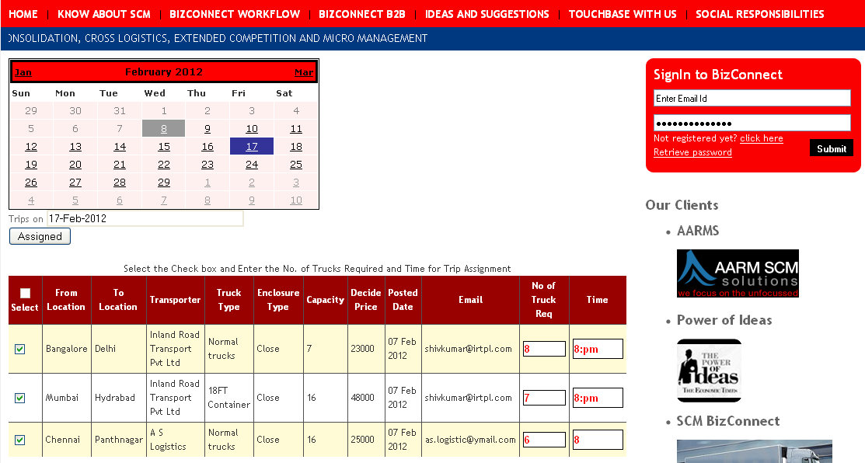

Trip Acceptance

Transporter who has Trip Agreements with clients keeps receiving, “Trip Assignment” mails from the clients with the link “Click here to confirm” whenever the clients prepares “Trip Assignments”.

If the Transporter finds a Trip Assignment okay, the transporter shall click the link.

Once he clicks the link, the Transporter will get the webpage shown below by automatically logging in to the SCMBizconnect. The Transporter can confirm his “Trip Acceptance” by pressing “Confirm Acceptance” after entering Vehicle No, Driver and Mobile No on the webpage shown below.

The client associated with the Transport Agreement will get the email indicating that the assignment made by the client to the transporter is accepted.

